

String Operations
12.10.2021
─
Rudra Chinhara
202117
B.Tech CSE
Central University of Haryana

Overview
WAP to implement the various operations on string such as
a) length of string
b) concatenation
c) reverse a string
d) copy a string
Here in this problem, you need to develop 4 functions which are meant to perform the given operations.

Code
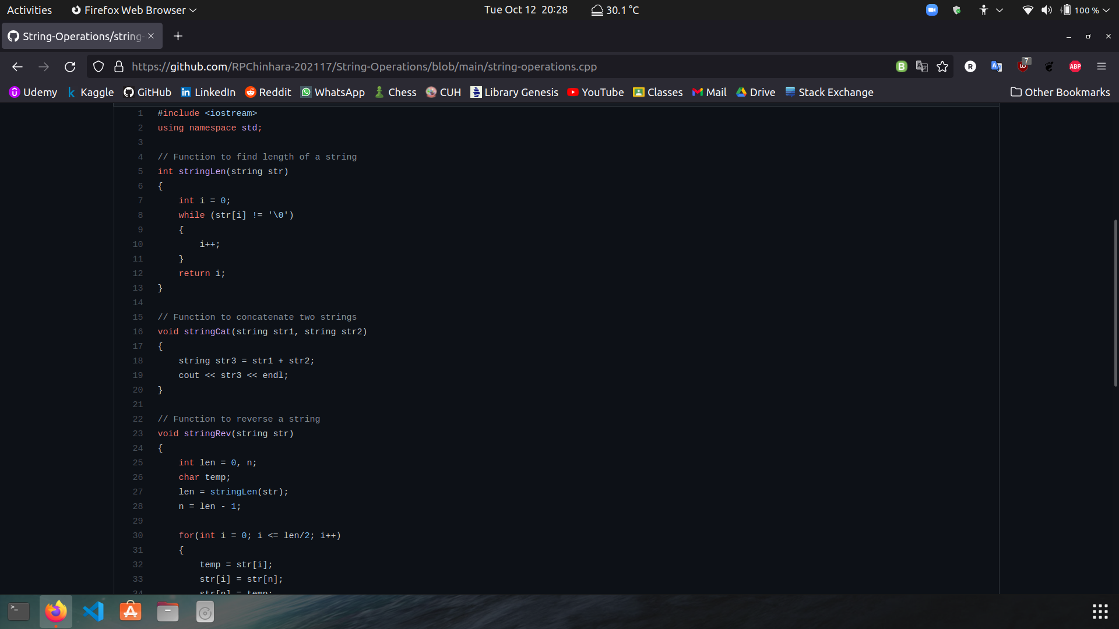

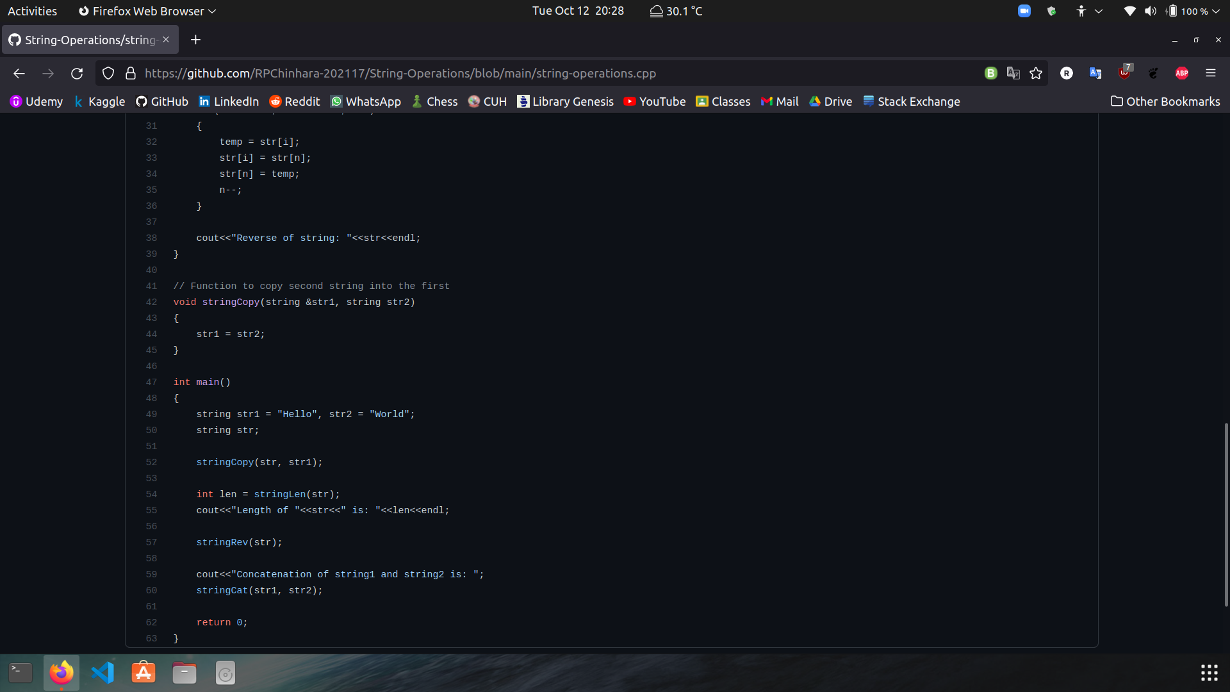

Terminal
